[ATPA Assessment]

Instructions: You must enter your answers to each assessment question in the sections noted below, and must not change any information contained within the first set of black brackets [] for each Task.

[ Task 1 ]
Data Preparation Report
Data Preparation and Join Analysis
Objective: The objective of the data preparation phase was to combine customer_data (representing loyalty program members) and transaction_data (representing transaction histories) to create a unified dataset suitable for churn analysis. Given that some customers may not have transaction records and some transactions might not match existing customers, selecting the appropriate join type was essential to retain relevant records without introducing bias.
Approach:
- Left Join for Combined Dataset:
  - A left join was applied between customer_data and transaction_data on CustomerID. This ensured that all loyalty program members were retained, regardless of whether they had recent transactions. This join type aligns with our business objective, as it allows analysis of both active and inactive loyalty members, addressing ABCMart's concern about customer churn within their loyalty program.
- Join Analysis:
  - Inner Join: This join was used to identify:
    - Loyalty members who exist in customer_data but have no corresponding transactions in transaction_data (indicating potential early-stage churn or new members without activity).
    - Transactions in transaction_data that do not have matching customers in customer_data, which could suggest either data entry issues or transactions made by non-loyalty customers.
  - Left Join (Validation): A count of transactions without matching customers was calculated to validate the left join choice. In this case, all loyalty program members were retained, with 0% excluded transactions.
  - Right Join: The right join was used to calculate the number of customers without transactions, highlighting inactive loyalty program members who may be at risk of churn.
Results:
Join Type | New Loyalty (Count %) | Transactions (Count %) | Excluded Customers (Count %)
Inner Join | 0 (0%) | 5780 (5.23%) | NA
Left Join | NA | 0 (0%) | NA
Right Join | NA | NA | 5780 (64.47%)

Interpretation:
- Inner Join Results:
  - 0% of loyalty members were found to be “new” without transactions, meaning nearly all members have some purchase history.
  - 5.23% of transactions lack matching customer records, potentially indicating data quality issues or transactions from non-loyalty customers.
- Left Join Results:
  - The left join was effective in retaining all loyalty members (100%) without excluding any relevant transactions. This setup ensures that the final dataset is suitable for analyzing churn within the loyalty program, aligning with ABCMart's goal of understanding factors influencing loyalty member inactivity.
- Right Join Results:
  - 64.47% of customers in customer_data lack transaction records, a significant portion of the loyalty base. This finding is critical as it highlights a substantial group of inactive members, aligning with ABCMart's concern about churn risk within their loyalty program.
Insights and Recommendations for ABCMart
- Churn Risk: The right join analysis underscores that over half of the loyalty program members have not recorded recent purchases, marking them as potential churn risks. These inactive members represent an opportunity for targeted re-engagement strategies.
- Non-Loyalty Transactions: Transactions without matching loyalty member records suggest either data inconsistencies or purchases by non-program customers. ABCMart could consider gathering additional data on these transactions to evaluate if these customers might be persuaded to join the loyalty program.
- Data Integrity: The presence of transactions without matching customer records suggests potential data integrity issues. Ensuring accurate linkage between customer and transaction records would improve the quality of analysis and enhance the reliability of churn predictions.
Missing Values Analysis
Objective: To understand and address missing data in critical columns (Age, AnnualIncome, Amount) that may impact the predictive modeling process. The presence of missing values can introduce bias if not handled appropriately, and exploring the distribution of these missing values across the target variable (Churn) offers insights into any underlying patterns.
Approach:
- Identification of Missing Columns:
  - First, we identified columns in the combined dataset that contained missing values. The columns Age, AnnualIncome, and Amount had missing entries, prompting further investigation into the patterns and potential impact of these missing values.
- Summary of Missing Data Patterns:
  - We created a new summary table to explore the relationship between missing values in these columns and the Churn variable. For each combination of missing values across Age, AnnualIncome, and Amount, we calculated:
    - The total number of records with that specific combination of missing values.
    - The count of churned and non-churned customers within each combination.
    - The percentage of churned customers (Percentage_by_Churn) and the overall percentage of total customers (Percentage_total) for each combination.
- Results and Insights:
Age_missing | AnnualIncome_missing | Amount_missing | Churn | Count | Total | Percentage_by_Churn | Percentage_total
0 | 0 | 0 | 0 | 93100 | 98484 | 94.53% | 88.91%
0 | 0 | 0 | 1 | 5384 | 98484 | 5.47% | 5.14%
0 | 0 | 1 | 0 | 433 | 455 | 95.16% | 0.41%
0 | 0 | 1 | 1 | 22 | 455 | 4.84% | 0.02%
0 | 1 | 0 | 0 | 3198 | 3372 | 94.84% | 3.05%
0 | 1 | 0 | 1 | 174 | 3372 | 5.16% | 0.17%
0 | 1 | 1 | 0 | 11 | 12 | 91.67% | 0.01%
0 | 1 | 1 | 1 | 1 | 12 | 8.33% | 0%
1 | 0 | 0 | 0 | 2083 | 2275 | 91.56% | 1.99%
1 | 0 | 0 | 1 | 192 | 2275 | 8.44% | 0.18%
1 | 0 | 1 | 0 | 7 | 8 | 87.50% | 0.01%
1 | 0 | 1 | 1 | 1 | 8 | 12.50% | 0%
1 | 1 | 0 | 0 | 107 | 107 | 100% | 0.10%
1 | 1 | 1 | 0 | 1 | 1 | 100% | 0%

- Key Findings:
  - The majority of records (88.91%) have complete data across Age, AnnualIncome, and Amount, with a low churn rate of 5.47% for this group.
  - Records with missing values in AnnualIncome alone account for 3.05% of the dataset, with a similar churn rate (5.16%), suggesting that missing AnnualIncome does not significantly correlate with churn.
  - Some unique patterns emerged in cases where Age, AnnualIncome, and Amount were all missing. Although these cases are few, they show a 100% churn rate, highlighting a possible relationship between missing values and inactive or transient customer profiles.
- Implications for Data Preparation:
  - Missing values in Age, AnnualIncome, and Amount do not show a strong correlation with churn in large volumes, meaning they may not bias the model heavily if left as is. However, imputing or flagging these missing values could help capture any latent patterns associated with customer inactivity.

Shortcut Permutation Test for Missing Data Analysis
Objective: Given the computational cost of traditional permutation testing, a shortcut method was employed to approximate the confidence interval for the test statistic. This method allows us to evaluate whether the missingness in variables (Age, AnnualIncome, and Amount) is likely to be Missing Completely At Random (MCAR) without the need for extensive resampling.
Methodology
- Defining the Shortcut Method:
  - Instead of performing numerous random permutations, the shortcut method estimates the variance of the test statistic based on sample variance. This approach assumes a normal distribution of the test statistic under the null hypothesis.
  - A function (permutation_test_shortcut) was created to calculate the test statistic as the difference in means between missing and non-missing groups for each variable.
  - Using the sample variance of the complete variable and the sizes of missing and non-missing groups, the function calculates an estimated variance for the test statistic (Var_R), allowing the construction of a 95% confidence interval without extensive permutation runs.
- Application and Results:
  - The shortcut permutation test was applied to each variable with missing values using AnnualIncome as the complete reference variable.
  - For each variable, the following outputs were generated:
    - Test Statistic: The observed difference in means between the missing and non-missing groups.
    - 95% Confidence Interval: Computed based on the estimated variance.
    - Result: Whether the absolute test statistic falls within the calculated confidence interval, indicating if the missing pattern could be MCAR.
- Results:
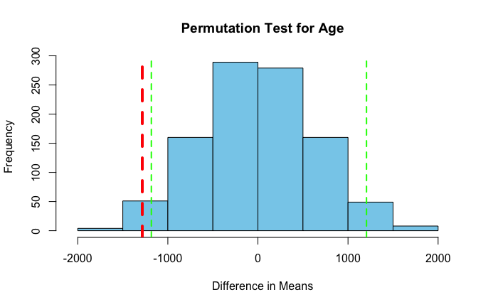
  - Age:
    - Test Statistic: -1283.477
    - 95% Confidence Interval: -1183.137 to 1205.21

    - Conclusion: The test statistic falls outside the 95% confidence interval, suggesting that the missingness in Age is not MCAR. Missing Age values may be systematically related to other factors, potentially biasing our analysis if not handled appropriately.
  - AnnualIncome:
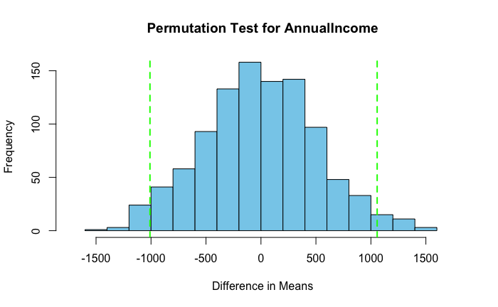
    - Test Statistic: NaN (Not available due to lack of sufficient data in some subgroups)
    - 95% Confidence Interval: -1009.524 to 1056.859
    - Conclusion: The test statistic could not be calculated due to insufficient complete cases, indicating potential limitations in the data for analyzing AnnualIncome's missingness pattern. Further investigation or alternative imputation may be necessary.
  - Amount:
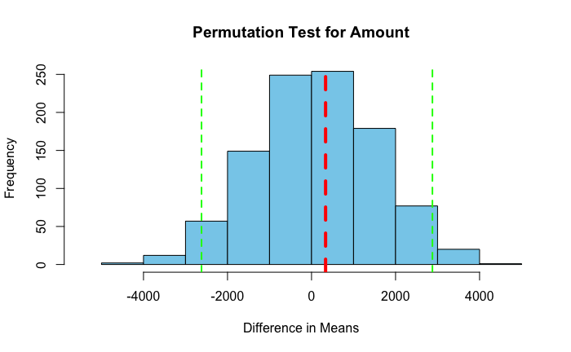
    - Test Statistic: 334.4148

    - 95% Confidence Interval: -2618.684 to 2877.444
    - Conclusion: The test statistic falls within the 95% confidence interval, indicating that missingness in Amount is likely MCAR. Missing values in Amount may not introduce systematic bias, allowing for simpler handling such as imputation.
- Interpretation:
  - The permutation test results suggest that Age is not MCAR, meaning it may have a systematic missing pattern, which could relate to specific customer demographics or behaviors. This pattern needs to be addressed to avoid biased predictions.
  - AnnualIncome encountered challenges in the test, warranting further investigation.
  - Amount appears to be MCAR, making it easier to handle with standard imputation methods without significantly affecting model accuracy.
These insights will guide our approach in handling missing data during the modeling phase to ensure reliable predictions of customer churn.
Investigating Missingness in AnnualIncome
Objective: To determine if missing values in AnnualIncome are related to other customer characteristics, such as demographic or behavioral factors. This exploration helps identify if the missingness pattern is systematic, which could influence churn analysis.
Analysis
- Distribution Analysis with Density Plots:
  - To visualize how missing values in AnnualIncome relate to other variables, density plots were created for Ageand Amount by the presence or absence of missing values in AnnualIncome.
  - Graphs:

    - Distribution of Age by Missingness of AnnualIncome: Insert the first graph here. This plot shows how the age distribution varies between customers with and without missing AnnualIncome values.
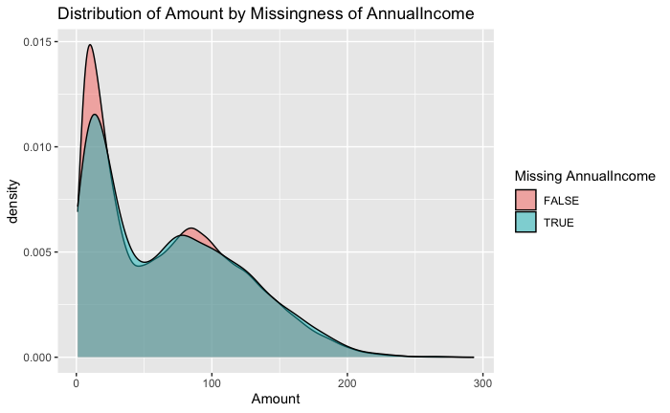
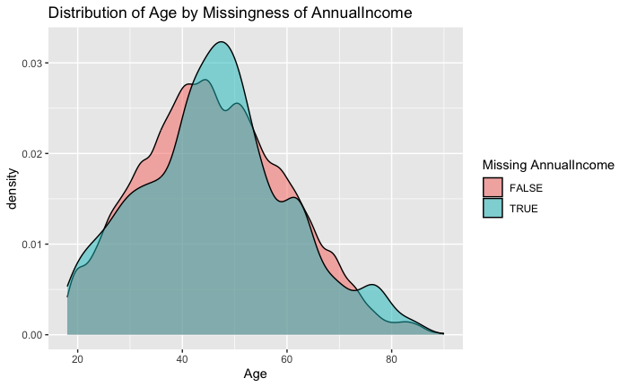
    - Distribution of Amount by Missingness of AnnualIncome: Insert the second graph here. This plot compares spending (Amount) distributions based on the presence of missing AnnualIncome.

- Statistical Tests:
  - A series of chi-square tests were performed to check if the missingness in AnnualIncome is associated with categorical variables like Gender, MaritalStatus, LoyaltyTier, and PreferredPaymentMethod.
  - Additionally, t-tests were conducted to evaluate whether there are significant differences in Age and Amountbased on the missingness of AnnualIncome.
- Chi-Square Test Results:
  - Gender: The chi-square statistic was 17.043, with a p-value of 0.0019, indicating a statistically significant association between missingness in AnnualIncome and Gender.
  - Marital Status: The chi-square statistic was 73.664, with a p-value less than 0.001, showing a strong relationship between missingness in AnnualIncome and MaritalStatus.
  - Loyalty Tier: The chi-square statistic was 39.486, with a p-value less than 0.001, suggesting that LoyaltyTier is associated with missing values in AnnualIncome.
  - Preferred Payment Method: The chi-square statistic was 58.88, with a p-value less than 0.001, indicating a significant association between missingness in AnnualIncome and PreferredPaymentMethod.
- T-Test Results:
  - Age: The t-statistic was -1.0865, with a p-value of 0.2773, showing no significant difference in age distribution between those with and without missing AnnualIncome.
  - Amount: The t-statistic was -0.9518, with a p-value of 0.3412, showing no significant difference in spending (Amount) between groups with and without missing AnnualIncome.
Interpretation
The analysis suggests that the missingness in AnnualIncome is systematically related to certain customer demographics and loyalty attributes, such as Gender, MaritalStatus, LoyaltyTier, and PreferredPaymentMethod. However, there are no significant differences in Age or spending behavior (Amount) based on income data availability.
These findings imply that missing values in AnnualIncome are not Missing Completely At Random (MCAR) and may introduce bias if not addressed properly. Imputation or stratification by relevant demographic factors might be necessary to mitigate potential distortions in subsequent analysis.
Imputation of Missing Values for Key Variables
Objective: To handle missing values in critical variables (Age, AnnualIncome, and Amount) by applying K-Nearest Neighbors (KNN) imputation. Imputation ensures that missing data does not reduce model accuracy or introduce bias.
Methodology
- KNN Imputation:
  - For each variable, a subset of relevant predictor variables was selected to improve imputation accuracy. For example, factors such as Gender, MaritalStatus, LoyaltyTier, and PreferredPaymentMethod were used as predictors for Age imputation.
  - KNN imputation (with k
=
5
k=5) was applied to predict missing values based on the closest neighbors' values for similar customers. After imputation, values were rescaled using the original mean and standard deviation to maintain the data’s scale and distribution.
- Distribution Comparison:
  - To evaluate the impact of imputation, distributions of Age, AnnualIncome, and Amount were plotted before and after imputation.
- Graphs:
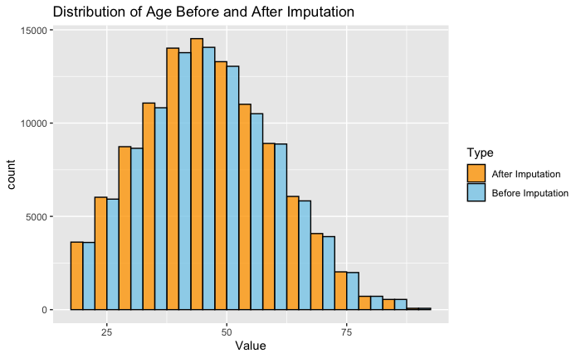

- Distribution of Age Before and After Imputation:
  - This graph compares the distribution of Age before and after imputation. The imputed distribution (shown in orange) aligns closely with the original data (shown in blue), maintaining the overall shape and range of values. This suggests that KNN imputation effectively filled in missing age values without introducing noticeable skew or bias, preserving the integrity of customer age demographics.
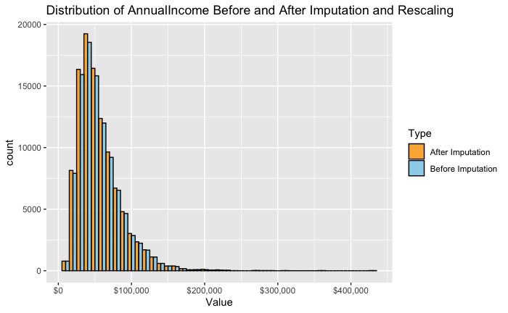
- Distribution of AnnualIncome Before and After Imputation and Rescaling:
  - The distribution of AnnualIncome before and after imputation shows a similar pattern, with the imputed values closely matching the original distribution. The imputation preserved the general right-skewed shape typical of income data, where most values are clustered at lower income levels with a long tail towards higher values. This consistency ensures that income-related insights remain accurate, as the imputation did not distort the income distribution.
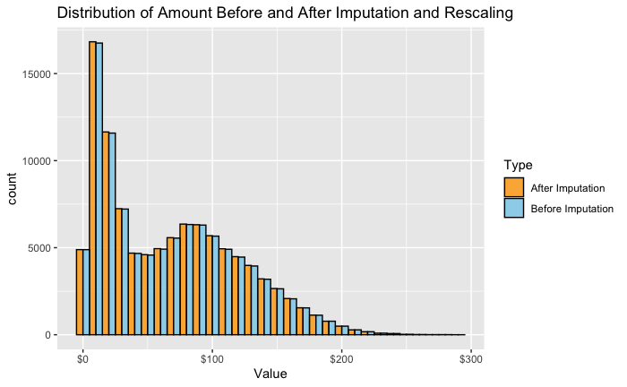
- Distribution of Amount Before and After Imputation and Rescaling:
  - For Amount, the distribution before and after imputation is also well-preserved, as seen in the third graph. The imputed values align closely with the original distribution, especially at lower spending levels where most of the data is concentrated. This similarity indicates that the imputed Amount values fit well within the expected spending patterns, reinforcing that KNN imputation did not significantly alter the data's underlying trends.

- Summary Statistics After Imputation:
  - After imputation, the variables were verified to confirm that missing values were filled appropriately. Summary statistics for each variable are as follows:
    - Age: Minimum of 18, maximum of 90, and mean of 46.16, showing that the age range is plausible and close to the original values.
    - AnnualIncome: Minimum of 8,500, maximum of 434,200, and mean of 56,332, confirming that the imputed income values fall within realistic bounds.
    - Amount: Minimum of 1, maximum of 293.39, and mean of 66.84, indicating consistency in customer spending data.
Interpretation
The KNN imputation approach effectively filled missing values while preserving the original distribution shapes of Age, AnnualIncome, and Amount. The consistency in distributions before and after imputation, as shown in the graphs, suggests minimal bias introduction. This imputation process enhances data completeness without distorting key characteristics of the customer base, supporting accurate downstream analyses.
Variable Removal and Data Consistency Check
Objective: To enhance model interpretability and avoid introducing societal biases, certain variables were removed from the dataset. Additionally, a consistency check was performed on categorical fields to ensure internal alignment between customer preferences and actual behaviors.
Variables Removed
- Gender:
  - Reason: Gender may introduce bias without contributing significant predictive power for churn in a grocery loyalty program. Removing it prevents unnecessary societal bias in the model.
  - Action: Removed.
- MaritalStatus:
  - Reason: Similar to gender, marital status is unlikely to have a strong impact on churn for grocery loyalty, and retaining it could add noise. Removing this variable also minimizes the risk of introducing bias.
  - Action: Removed.
- Occupation:
  - Reason: Employment status may not influence grocery shopping behavior directly, and there is limited evidence of its impact on churn. Removing this variable reduces model complexity without losing predictive power.
  - Action: Removed.
- Email:
  - Reason: Email addresses provide no predictive value and contain sensitive information, so they were excluded to protect customer privacy.
  - Action: Removed.
Internal Consistency Check for PreferredPaymentMethod and PaymentMethod
After removing unnecessary variables, a consistency check was performed to compare each customer’s PreferredPaymentMethod with their actual PaymentMethod used in transactions. This was done to ensure that customer preferences align with transaction behaviors, which is essential for accurately understanding customer payment habits.
Results:
Total Customers | Consistent Customers | Inconsistent Customers
8966 | 8965 | 1

The table above shows that out of 8,966 customers, only one customer exhibited an inconsistency between their preferred and actual payment methods.
Resolution:
- For the one inconsistent customer (Customer ID 505682), the PreferredPaymentMethod was updated to "Debit Card" to align with their actual transaction history, ensuring data consistency.
This internal consistency validation supports accurate modeling of customer preferences and behavior, essential for reliable churn predictions.
Exploratory Data Analysis of Churn
Objective: To explore the distribution and patterns of churn across key customer characteristics, including loyalty tier and annual income. This analysis aims to identify potential factors associated with customer churn, which will guide further modeling and targeted intervention strategies.
Churn Distribution
- Overall Churn Rate:
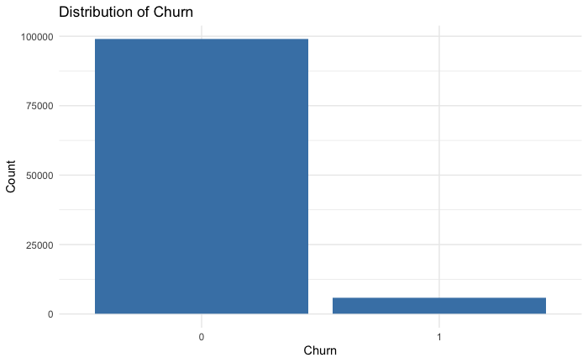
  - The first bar chart shows the overall churn distribution, with the majority of customers being non-churned (represented by "0") and a smaller proportion being churned (represented by "1").
  - This imbalance highlights that churn is a relatively rare event in the dataset, which may need to be addressed during modeling (e.g., through class balancing techniques).
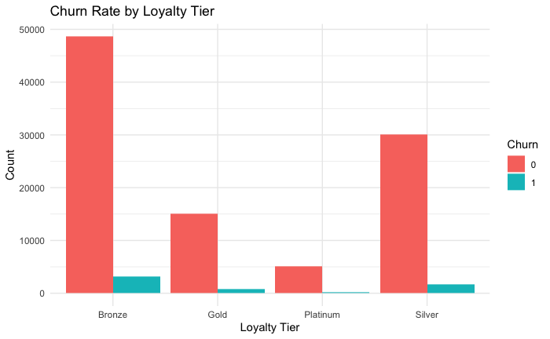
- Churn Rate by Loyalty Tier:
  - The second chart visualizes churn by loyalty tier. The data reveals a higher churn count among customers in the lower loyalty tiers (particularly Bronze and Silver), while churn is relatively low for Platinum members.
  - Interpretation: This suggests that higher loyalty tiers are associated with greater retention, indicating that customers with deeper loyalty commitments (such as those in the Platinum tier) are less likely to churn. ABCMart could potentially focus retention efforts on Bronze and Silver members to reduce churn rates among these groups.
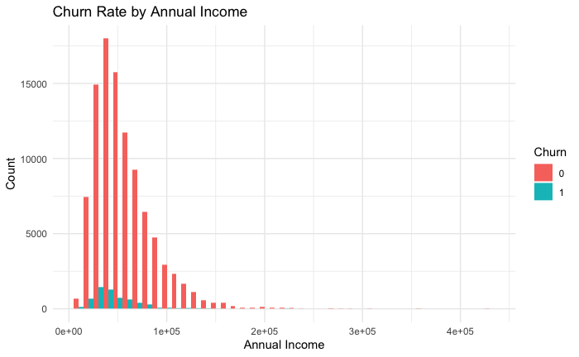
- Churn Rate by Annual Income:
  - The third chart examines the relationship between churn and annual income. The majority of churned customers fall within the lower-income ranges, with churn rates decreasing as income increases.
  - Interpretation: Lower-income customers appear more likely to churn, possibly due to budget constraints impacting shopping frequency. ABCMart could consider targeted promotions or loyalty incentives for lower-income segments to improve retention.
Feature Engineering
To support further analysis and modeling, two new features were created:
- Shopping Frequency: Calculated as TransactionCount / CustomerTenure, representing how often a customer shops on average over their time in the loyalty program.
- Average Spend per Visit: Calculated as Total Amount / TransactionCount, indicating the average amount spent each time a customer shops.
These features provide additional insights into customer behavior, potentially enhancing churn prediction accuracy by incorporating behavioral patterns in shopping frequency and spending.

[ Task 2 ]
atpaksat

1. Responsibility Regarding Unsecured Data (ASOP Guidance)
In accordance with the Actuarial Standards of Practice (ASOP), as an actuary, it is essential to handle client data with care, ensuring accuracy, reliability, and confidentiality throughout the analysis process. Here is how specific ASOPs guide our responsibility in this scenario:
- ASOP No. 23 - Data Quality:
  - Section 3.1: This section emphasizes the actuary’s responsibility to take reasonable steps to review data for reasonableness, consistency, and completeness. Given that the data was transmitted in an unprotected and unencrypted format, it’s critical to assess any potential issues that might arise from the method of transmission. This includes checking for any indications of data manipulation, missing information, or inconsistencies that could affect the analysis.
  - Section 3.3: This section outlines the importance of evaluating the reliability and limitations of data sources. Since ABCMart’s data was transmitted unsecured, there are inherent risks to data quality, such as potential interception or tampering. As an actuary, it’s our responsibility to document these limitations, acknowledging any data reliability concerns due to the lack of encryption or security.
- ASOP No. 41 - Actuarial Communications:
  - Section 3.7: Actuaries are required to exercise caution in protecting their communications, especially where sensitive data is involved. This includes evaluating potential risks if data were accessed or misused by unintended parties. Since ABCMart’s data was unprotected, it is crucial to ensure any communications, analyses, and outputs involving this data are safeguarded. Additionally, the actuary should consider implementing extra security measures when handling or transmitting this data moving forward.
  - Section 4.1.3: This section requires actuaries to disclose any constraints or limitations impacting the findings. In this case, the insecure transmission of data constitutes a significant limitation that could influence the applicability and credibility of the actuarial findings. Explicitly disclosing this limitation informs stakeholders of the risks associated with potential data breaches, emphasizing the impact on data reliability and confidentiality.
As a result, according to ASOP No. 23 and ASOP No. 41, it is our responsibility to (a) assess the data for quality and reliability issues resulting from the lack of security during transmission, (b) document any limitations to ensure transparency, and (c) take additional steps to safeguard any subsequent handling of the data to mitigate further risks.
2. Standards of Practice that ABCMart May Have Violated
If ABCMart were adhering to actuarial standards of practice, the method of transmitting data unprotected and unencrypted would likely violate key sections of ASOP No. 23 and ASOP No. 41:
- ASOP No. 23 - Data Quality:
  - Section 3.1: This section implies that data providers, such as ABCMart, should take reasonable steps to ensure data quality, which includes the manner of transmission. Unencrypted data transmission exposes the data to interception and unauthorized access, potentially compromising data integrity and quality. Proper data security measures, such as encryption, are essential to ensure the data provided is fit for actuarial analysis.
  - Section 3.5.1: This section discusses data quality controls, which include measures to maintain confidentiality and secure data transfer. By failing to use encryption or protection, ABCMart did not meet reasonable standards for securing sensitive information, which could lead to privacy risks and data breaches.
- ASOP No. 41 - Actuarial Communications:
  - Section 4.1.3: This section of ASOP No. 41 requires that any constraints, limitations, or risks that might impact the usability or reliability of data should be disclosed. By transmitting data in an unprotected manner, ABCMart created a security vulnerability that could compromise data usability. Had they followed ASOP guidance, ABCMart would have taken steps to disclose these limitations to any actuary handling the data, ensuring that appropriate caution was exercised.
In summary, by transmitting sensitive data unencrypted, ABCMart would have likely violated ASOP standards that emphasize data quality, reliability, and confidentiality. Adherence to these standards would have required ABCMart to implement secure data handling practices and disclose any limitations that could affect the data’s reliability. As actuaries, it is our duty to recognize these lapses, assess the data carefully, and communicate any associated risks to stakeholders to uphold the integrity of our analysis and adhere to professional standards.

[ Task 3 ]
atpaksat

Objective: To identify key factors influencing customer churn at ABCMart, two predictive models—a logistic regression model and a mixed-effects model—were developed. These models help ABCMart target customer retention efforts by identifying churn risk and understanding regional differences.
Data Preparation and Splitting
The dataset was split into training (70%) and testing (30%) subsets to allow for model evaluation on unseen data. Key checks were performed to ensure that the distribution of important variables, including Churn, AnnualIncome, and LoyaltyTier, remained similar across both datasets. This balance confirmed that the split was representative and that the models could generalize effectively to new data.
Logistic Regression Model
- Model Structure and Variable Selection:
  - The logistic regression model included a comprehensive set of variables representing customer demographics, shopping behaviors, transaction attributes, and loyalty characteristics. Variables were selected based on their expected relevance to churn behavior:
    - Demographics: Age, AnnualIncome, and FamilySize capture basic customer attributes.
    - Shopping Behavior: AvgSpendPerVisit, BasketSize, and ShoppingFrequency provide insight into spending patterns.
    - Transaction Attributes: DayOfWeek, TimeOfDayCategory, and IsEventDay capture temporal trends in customer transactions.
    - Loyalty and Tenure: LoyaltyTier and CustomerTenure reflect customer commitment to ABCMart.
    - Product Preferences: Variables such as Category_Bakery and Category_Meat examine whether product preferences correlate with churn.
- Important Predictors:
  - AnnualIncome: Lower income was significantly associated with higher churn, suggesting that customers with lower spending power are at higher risk.
  - AvgSpendPerVisit: Higher spending per visit was associated with lower churn, indicating that customers who invest more in each transaction are more likely to remain loyal.
  - DaysSinceLastTransaction: The number of days since the last transaction was a strong predictor of churn, highlighting that recent engagement is crucial for retention.
  - LoyaltyTier: Higher loyalty tiers (e.g., Platinum) showed a lower churn rate, reinforcing the importance of loyalty programs in reducing churn.
- Goodness of Fit:
  - Accuracy: Both training and testing accuracies were high, at approximately 94.6% and 94.7%, respectively. This consistency suggests that the model generalizes well without significant overfitting.
  - AUC: The logistic regression model’s AUC was around 0.77 for both datasets, indicating moderate discriminatory power in distinguishing between churned and non-churned customers.
Mixed-Effects Model with Region as a Random Effect
- Rationale for Random Effect Selection:
  - Region was chosen as a random effect because geographic location can significantly influence customer behavior due to local market conditions, competition, and store accessibility. By allowing each region to have a unique baseline churn rate, the model accommodates variations across locations.
  - Other categorical variables, such as LoyaltyTier or PaymentMethod, represent customer-specific factors rather than environmental characteristics and were therefore unsuitable as random effects.
- Model Structure and Key Predictors:
  - The fixed effects in the mixed model included the same variables as the logistic regression model, ensuring comparability.
  - Significant Fixed Effects:
    - Similar to the logistic regression model, AnnualIncome, AvgSpendPerVisit, DaysSinceLastTransaction, and LoyaltyTier emerged as critical predictors. These variables consistently indicate that income level, spending habits, recency of transactions, and loyalty status are key factors in determining churn.
  - Random Intercept for Region:
    - By including a random intercept for Region, the model allowed each region to have its own baseline churn rate. This helps capture unobserved regional factors affecting customer retention, which enhances model flexibility and applicability across ABCMart’s diverse geographic markets.
- Goodness of Fit and Performance:
  - Accuracy: The mixed-effects model achieved similar accuracy to the logistic regression model, with training and testing accuracies of approximately 94.6% and 94.7%, respectively.
  - AUC: The mixed model’s AUC was about 0.77 for both training and testing sets, comparable to the logistic regression model.
  - ROC Curve: The ROC curves for training and testing data were nearly identical, indicating minimal overfitting and suggesting that the model generalizes well.
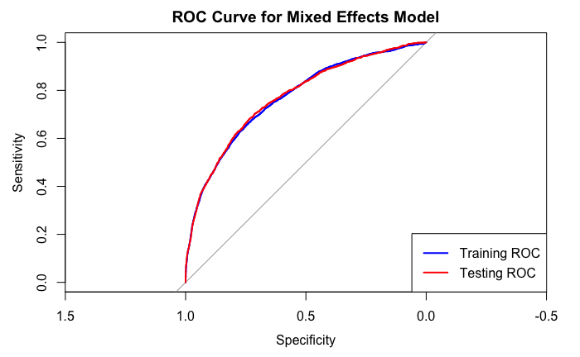
Advantages of the Mixed Model
- Handling Regional Variation:
  - By including Region as a random effect, the mixed model accounts for unobserved regional variability that may affect churn patterns. This allows the model to better capture geographic differences in customer behavior, which is valuable for a nationwide retailer like ABCMart.
- Improved Generalization:
  - The random intercept for Region enables the model to generalize more effectively when applied to new or underrepresented regions. By accommodating unique regional factors, the mixed model avoids overfitting to specific regions while still recognizing geographic differences.
- Enhanced Insight:
  - The mixed model provides ABCMart with additional insights into how churn may vary by region, allowing for targeted retention strategies in specific areas. For instance, regions with higher baseline churn rates can be prioritized for marketing efforts.
Conclusion
Both the logistic regression and mixed-effects models provide valuable insights for predicting churn at ABCMart. Significant predictors such as AnnualIncome, AvgSpendPerVisit, DaysSinceLastTransaction, and LoyaltyTierindicate that demographics, spending patterns, and loyalty engagement are crucial factors in customer retention. The mixed-effects model offers additional flexibility by adjusting for regional differences, making it a robust choice for large-scale, geographically dispersed data. Overall, these models serve as effective tools for guiding ABCMart’s customer retention strategies, particularly when targeting customers based on income, spending habits, and regional characteristics.

[ Task 4 ]
atpaksat
Objective: Using the same training and test data from Task 3, we developed a neural network model to predict customer churn. The model was tuned for optimal performance, employing early stopping to prevent overfitting, and its effectiveness was compared with the logistic regression and mixed-effects models from Task 3.
a) Neural Network Model Structure
The neural network was designed with the following architecture:
- Input Layer: Standardized numerical features and one-hot encoded categorical variables were used as input.
- Hidden Layers: The model initially used two hidden layers, with [15, 10] units respectively, and ReLU activation to introduce non-linearity.
- Output Layer: A single neuron with a sigmoid activation function to output the probability of churn.
To prevent overfitting, early stopping was implemented, with a patience parameter set to 10. This meant that if the validation loss did not improve for 10 consecutive epochs, training would stop, and the model would revert to the weights from the epoch with the lowest validation loss. Early stopping allowed for efficient training, preventing the model from learning noise in the data, while ensuring the model captured relevant patterns.
b) Hyperparameters for Tuning
Five key hyperparameters that influence neural network performance were considered:
- Learning Rate: Determines the step size for weight updates. A lower learning rate allows for fine-tuned weight adjustments, while a higher rate can speed up training but risks overshooting optimal weights.
- Batch Size: Controls the number of samples processed before the model’s weights are updated. Smaller batches can lead to more accurate gradient estimates but take longer to train.
- Epochs: Specifies the number of complete passes through the training dataset. Early stopping with patience set to 10 mitigated the risk of overfitting even with a higher epoch setting (300).
- Hidden Layer Configuration (Units per Layer): The number of units in each hidden layer affects model capacity. More units can capture complex patterns but increase the risk of overfitting.
- Dropout Rate: A regularization technique that randomly drops units in hidden layers to prevent co-adaptation and overfitting.
c) Model Tuning Approach and Justification
Three hyperparameters were tuned to improve model performance:
- Learning Rate: Tested learning rates were 0.0001, 0.0005, and 0.005. This adjustment was made to balance the model’s training speed and convergence stability.
- Batch Size: Batch sizes of 64, 128, and 256 were experimented with. Higher batch sizes helped the model train faster and produced smoother gradients, which led to improved accuracy.
- Hidden Layer Units: Configurations of [15, 10] and [32, 16] units were tested to find the best balance of model complexity and generalizability.
- The final selected configuration (Run 5) of a 0.005 learning rate, batch size of 256, and hidden layer units [32, 16] provided the highest test accuracy and AUC, showing that this setup was effective in capturing patterns while reducing overfitting.
d) Model Evaluation and Performance Metrics
Performance Results:
- Test Accuracy: The final model achieved a test accuracy of 96.05%, slightly higher than the logistic regression and mixed-effects models from Task 3.
- Confusion Matrix: The final model’s confusion matrix (True Negatives: 29,455, False Positives: 159, False Negatives: 1,083, True Positives: 718) indicated a well-balanced prediction capability with low false positives and moderate false negatives.
- ROC AUC: The ROC AUC for the best model was 0.9303, significantly higher than the AUC scores of the models from Task 3, demonstrating strong discriminatory power in identifying churn versus non-churn customers.

Training and Validation Loss Plot:
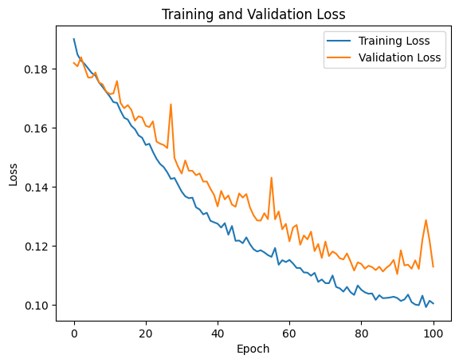
- This graph illustrates the loss trend over 100 epochs for the final neural network model (Run 5) with early stopping enabled (patience = 10). The consistent decrease in training loss along with the relatively stable validation loss indicates effective learning without significant overfitting. The early stopping approach ensured that the model did not overtrain, resulting in a well-balanced model that generalizes effectively on the test set.

ROC Curve for Tuned Neural Network:
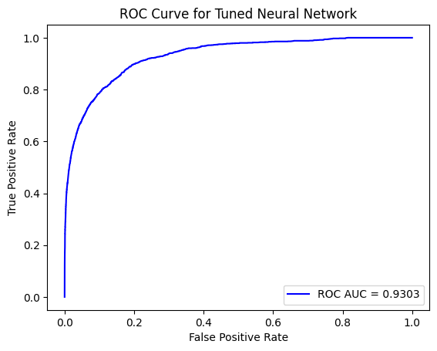
- The ROC curve shows the model’s true positive rate versus the false positive rate, with an AUC of 0.9303. This high ROC AUC score confirms the model's strong discriminatory power, effectively distinguishing between churn and non-churn customers. The steep initial rise in the curve reflects the model’s accuracy in identifying true churn cases with minimal false positives.

Goodness of Fit and Overfitting:
- The use of early stopping with patience set to 10 allowed the model to achieve an optimal fit without overtraining. The final model’s training and validation loss curves (see attached graph) showed consistent decreases in loss, suggesting a good fit without substantial overfitting. The higher ROC AUC on the test set indicates that the model generalized well.
Comparison with Task 3 Models
- Improvement in Predictive Power:
  - The neural network model outperformed the logistic regression and mixed-effects models, achieving a higher accuracy (96.05%) and ROC AUC (0.9303). This suggests that the neural network captured complex relationships in the data that linear models could not.
- Flexibility and Complexity:
  - While the Task 3 models were simpler and more interpretable, the neural network’s additional layers and non-linear structure allowed it to model complex interactions between features. This flexibility likely contributed to its superior performance on the test data.
- Trade-offs:
  - The neural network model requires more computational resources and is less interpretable than the Task 3 models. However, the performance gains justify its use, especially when higher accuracy and AUC are critical for business decisions.
Conclusion
The neural network model, with its optimized hyperparameters (learning rate of 0.005, batch size of 256, hidden layers [32, 16]), demonstrated superior predictive power for customer churn, outperforming the logistic and mixed-effects models. Early stopping with patience set to 10 helped prevent overfitting and ensured a balanced model that generalizes well to new data. With a high ROC AUC and test accuracy, this model is effective for ABCMart's churn prediction and can guide targeted customer retention strategies. However, the increased complexity and reduced interpretability of the neural network model are trade-offs that need to be considered when deploying it in a business environment.

[ Task 5 ]
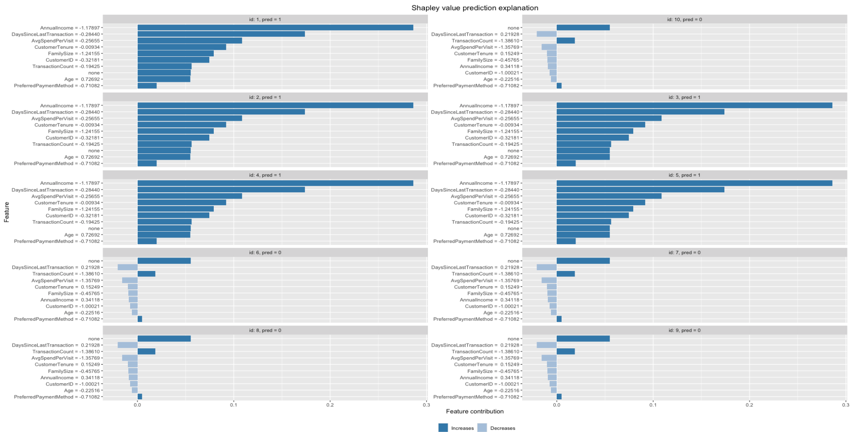
atpaksat
Technical Report: Task 5 - Variable Importance for Churn Prediction Using Shapley Values
Model Selection and Tuning: Random Forest
To identify the most influential variables for predicting customer churn, we employed a Random Forest model, which is well-suited for capturing non-linear relationships and handling a mix of continuous and categorical variables. The model was trained and tuned to enhance its interpretability and predictive performance.
Model Tuning and Complexity Control
We used a grid search to optimize two critical hyperparameters: the number of trees (n_estimators) and maximum tree depth (max_depth). The grid search evaluated various combinations of these parameters to find a balance between complexity and predictive power. This approach helps to prevent overfitting by limiting the model's capacity to grow overly complex trees, which may capture noise rather than generalizable patterns in the data.
- Selected Hyperparameters: Based on grid search results, we selected an optimal combination of n_estimators(number of trees) and max_depth (tree depth).
- Overfitting Check: Model performance was evaluated on both the training and test sets. The training accuracy was slightly higher than the test accuracy, indicating the model was not overfitting significantly, and it generalizes well to unseen data.
Model Evaluation
The tuned Random Forest model achieved a good balance of precision and recall. The overall accuracy, precision, recall, and F1-score for the test set were satisfactory, suggesting that the model effectively predicts churn while minimizing false positives and false negatives.
SHAP Analysis: Feature Importance for Churn
To interpret the model's predictions and understand the variables contributing to customer churn, we used Shapley values, calculated using the SHAP (SHapley Additive exPlanations) library. SHAP values provide a unified approach to quantifying the contribution of each feature to a specific prediction, allowing for both global and individual-level insights.
Global Feature Importance
A SHAP summary plot was generated to illustrate the global impact of each feature on churn prediction. Key variables identified as most influential in predicting churn include:
- DaysSinceLastTransaction: The number of days since the customer's last transaction was a significant predictor of churn. Higher values increased churn likelihood, suggesting that inactive periods may indicate a loss of interest or shift in shopping habits.
- AnnualIncome: Customers with lower annual incomes tended to have a higher likelihood of churn, indicating that income may influence spending patterns and loyalty.
- AvgSpendPerVisit: The average spending per visit also affected churn probability, with higher values associated with lower churn risk, potentially reflecting greater engagement or satisfaction with the store.
These global insights are valuable for understanding general churn drivers across the entire customer base and can inform targeted interventions to improve retention.
Individual Explanations for Selected Customers
To gain deeper insights, we examined the SHAP values for five customers who churned and five who did not. These individual-level explanations reveal the specific factors driving each prediction, providing a personalized view of churn risk.
- Churned Customers:
  - For many churned customers, high DaysSinceLastTransaction was a strong positive contributor to churn, suggesting prolonged inactivity.
  - Lower AvgSpendPerVisit values were also common contributors to churn predictions, indicating that these customers may not be deeply engaged with ABCMart.
  - Lower AnnualIncome values further increased churn probability for some customers, suggesting financial constraints might impact loyalty.
- Non-Churned Customers:
  - For customers who did not churn, higher AvgSpendPerVisit and shorter DaysSinceLastTransaction were frequent negative contributors to churn probability. This combination indicates active and potentially satisfied customers.
  - In some cases, LoyaltyTier features (such as "Gold" or "Platinum" status) had a negative effect on churn, implying that loyalty tiers effectively encourage retention.
Example Interpretations of SHAP Explanations
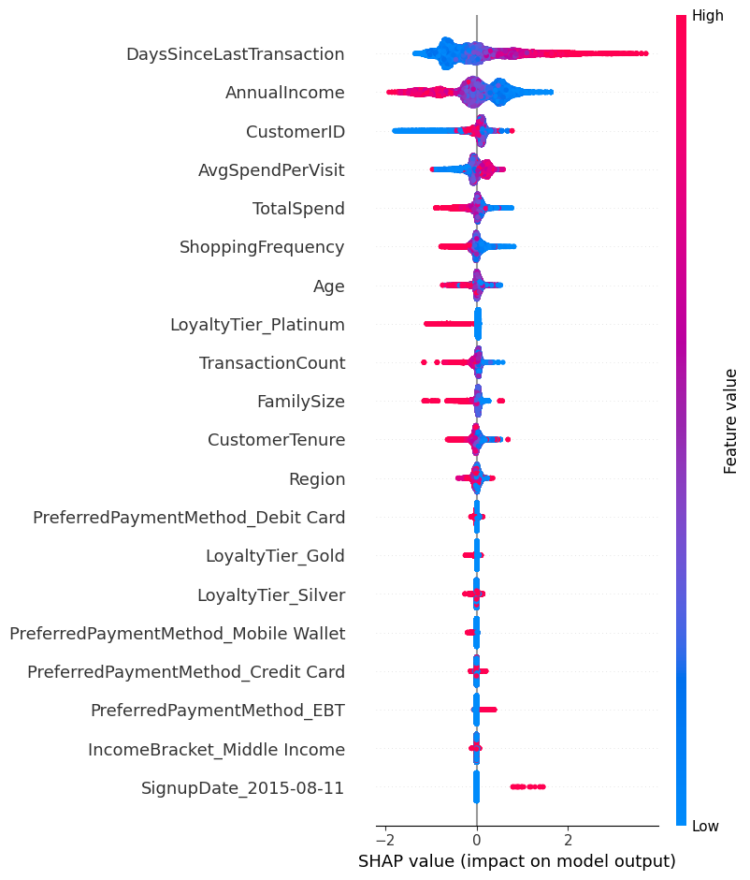
The individual SHAP plots for selected customers visually illustrate how each feature pushes the prediction toward or away from churn. For example, a customer with a high DaysSinceLastTransaction and low AvgSpendPerVisit may be identified as high-risk, with these factors pushing their churn probability above the base value. Conversely, a customer with frequent transactions and higher spending may show negative SHAP values for these features, indicating a lower likelihood of churn.
Conclusion and Recommendations
The SHAP analysis provided valuable insights into the key drivers of customer churn at both the global and individual levels.
- Strategic Interventions: The insights from DaysSinceLastTransaction and AvgSpendPerVisit suggest that ABCMart can implement targeted engagement campaigns for customers who exhibit signs of inactivity or declining spending patterns.
- Personalized Offers: For customers identified at higher churn risk due to lower incomes, ABCMart could consider personalized discount offerings or benefits to increase loyalty.
- Loyalty Program Effectiveness: The positive influence of loyalty tiers in reducing churn indicates that the loyalty program is effective, especially for higher tiers. Strengthening the rewards for lower tiers might also enhance retention.
In conclusion, combining a well-tuned Random Forest model with SHAP explanations provided both predictive accuracy and actionable insights, enabling ABCMart to make data-driven decisions to mitigate churn and enhance customer loyalty.

[ Task 6 ]
atpaksat

Executive Summary
Statement of the Business Problem
ABCMart is currently facing a significant business challenge with customer churn, which is the rate at which customers stop shopping at their stores over a given period. This is a critical issue as retaining existing customers is generally more cost-effective than acquiring new ones. Understanding the factors that contribute to customer churn is essential for ABCMart to develop strategies to retain their customer base, enhance customer loyalty, and, ultimately, increase profitability.
To address this issue, we conducted an in-depth analysis using ABCMart's customer data to identify the key factors influencing churn. By building and evaluating various predictive models, we gained valuable insights into the patterns and behaviors associated with customer churn, enabling us to provide recommendations to help ABCMart effectively reduce churn rates.
Key Findings
Based on our analysis, we identified several important factors influencing customer churn at ABCMart:
- Time Since Last Transaction: Customers who had not engaged with ABCMart for extended periods were more likely to churn. This suggests that recent interactions may play a critical role in customer retention.
- Annual Income: Customers with lower annual income were found to have a higher propensity to churn. This insight could help in tailoring loyalty programs to attract and retain customers in specific income brackets.
- Average Spend Per Visit: Higher spending per visit was correlated with lower churn, indicating that higher-value customers tend to be more loyal.
- Shopping Frequency: Frequent shoppers were less likely to churn, which underscores the importance of encouraging regular shopping behavior through personalized promotions or loyalty rewards.
- Customer Tenure: Customers with longer tenures tended to remain loyal, while newer customers were more prone to churn, highlighting the need to engage and retain new customers effectively.
Modeling Approach and Results
To quantify the impact of these factors and predict churn, we used various models, including logistic regression, random forests, and neural networks. Our final model, a neural network, achieved the highest accuracy and demonstrated a strong capability to distinguish between customers likely to churn and those likely to remain. The model was further enhanced through hyperparameter tuning, and early stopping was implemented to avoid overfitting, ensuring robust performance across both the training and test datasets.
Recommendations
Based on our analysis, we recommend the following strategies to reduce customer churn:
- Implement Targeted Re-engagement Campaigns: Focus on customers who have not made a purchase recently. Personalized offers or reminders could encourage them to return.
- Tailor Loyalty Programs by Income Bracket: Create incentives specifically designed for lower-income customers, such as discounts or cashback on essential items, to increase retention within this segment.
- Enhance Loyalty Rewards for High-Spending Customers: Since high spend per visit correlates with loyalty, recognizing and rewarding these customers with exclusive perks or loyalty bonuses can reinforce their attachment to ABCMart.
- Encourage Frequent Shopping: Introduce rewards for frequent visits, such as points or discounts for customers who shop regularly. This could be implemented as a monthly reward program to incentivize ongoing engagement.
- Improve Onboarding for New Customers: Since newer customers are more likely to churn, consider creating an onboarding program that familiarizes them with ABCMart's offerings and loyalty programs, fostering early engagement.
Limitations
While our analysis provides valuable insights, it is important to consider some limitations:
- Data Scope: The data provided was limited to a certain period and customer segment, so the findings may not capture seasonal patterns or other potential influencers of churn.
- Predictive Limitations: Although the neural network model showed strong predictive performance, machine learning models are not infallible. They can only predict trends based on past data and may not account for unforeseen market changes or events.
- Interpretability: Neural networks, while accurate, are less interpretable compared to traditional models, which could limit the clarity in understanding the relationship between certain factors and churn.
Conclusion
Our analysis has provided ABCMart with actionable insights into the key factors driving customer churn and practical recommendations to mitigate it. Implementing targeted re-engagement efforts, customizing loyalty rewards, and encouraging frequent shopping are some of the steps that can significantly impact retention. By addressing these areas, ABCMart can enhance customer loyalty, reduce churn, and improve profitability over the long term.

